SQL LIKE Operator

- The SQL Server LIKE operator is a logical operator that checks if a character string matches a specified pattern.
- A pattern may include regular characters and wildcard characters
- Used with WHERE Clause
Wild Cards
A wildcard character is used to substitute one or more characters in a string.
- The percent wildcard (%): any string of zero or more characters.
- The underscore (_) wildcard: any single character.
- The [list of characters] wildcard: any single character within the specified set.
- The [character-character]: any single character within the specified range.
- The [^]: any character that is not within a list or a range.

SQL LIKE operator examples

Using the LIKE operator with the % wildcard
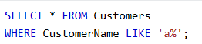
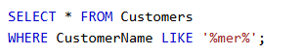
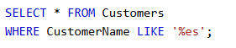

- Using the LIKE operator with the _ (underscore) wildcard
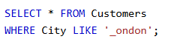

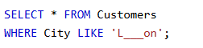
- Using the LIKE operator with the [list of characters] wildcard

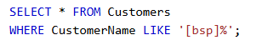
Explanation:
- Starts with b ,s or p

- Using the LIKE operator with the [character-character] wildcard

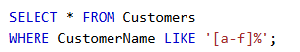
[A-C] means → any character between A and C

- Using the LIKE operator with the [^Character List or Range] wildcard

SELECT * FROM Emp WHERE Name LIKE '[^AB]%'
First letter must NOT be A or B

The SQL IN Operator
The IN operator allows you to specify multiple values in a WHERE clause.
The IN operator is a shorthand for multiple OR conditions.
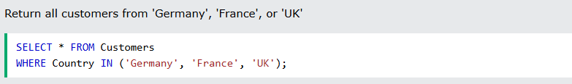
The SQL IN operator is used to check if a column value matches any value in a list.
Instead of writing multiple OR conditions, you can use IN.

Basic Syntax
SELECT column_name
FROM table_name
WHERE column_name IN (value1, value2, value3);

Simple example

Customers table:
CustomerId | Name | City
1 | Anu | London
2 | Ravi | Paris
3 | Meera | Berlin
4 | John | London
5 | David | Paris

Query using IN:
SELECT *
FROM Customers
WHERE City IN ('London', 'Paris');

Meaning:
Find customers whose City is either London OR Paris

Output:
CustomerId | Name | City
1 | Anu | London
2 | Ravi | Paris
4 | John | London
5 | David | Paris

Same query using OR
SELECT *
FROM Customers
WHERE City = 'London' OR City = 'Paris';
IN is just a shorter way of writing this.

SQL BETWEEN Operator

The BETWEEN operator selects values within a given range. The values can be numbers, text, or dates.
The BETWEEN operator is inclusive: begin and end values are included.

The SQL BETWEEN operator is used to select values within a range.
It works with:
- Numbers
- Dates
- Text
👉 Important: BETWEEN includes both start and end values.

Syntax
SELECT column_name
FROM table_name
WHERE column_name BETWEEN value1 AND value2;
Means:
column_name >= value1 AND column_name <= value2

Example 1: Using Numbers

Emp table:
EmpId | Name | Salary
1 | Anu | 10000
2 | Ravi | 20000
3 | Meera | 30000
4 | John | 40000

Query:
SELECT *
FROM Emp
WHERE Salary BETWEEN 15000 AND 35000;

Output:
EmpId | Name | Salary
2 | Ravi | 20000
3 | Meera | 30000

Explanation:
Select salary between 15000 and 35000
Includes both 15000 and 35000

Example 2: Using Dates

Orders table:
OrderId | OrderDate
1 | 2024-01-10
2 | 2024-02-15
3 | 2024-03-20

Query:
SELECT *
FROM Orders
WHERE OrderDate BETWEEN '2024-01-01' AND '2024-02-28';

Output:
OrderId | OrderDate
1 | 2024-01-10
2 | 2024-02-15

Example 3: Using Text
SELECT *
FROM Customers
WHERE Name BETWEEN 'A' AND 'M';
Returns names starting from A to M.

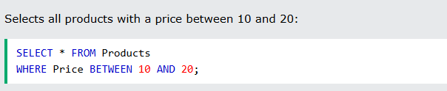

The LIKE operator in SQL Server is used to search for a specific pattern in a column.
It is mostly used with the WHERE clause.

Syntax
SELECT column_name
FROM table_name
WHERE column_name LIKE pattern;

Wildcard characters used with LIKE
Wildcard | Meaning | Example
% | Any number of characters | 'A%'
_ | Only one character | 'A_'
[] | Match any character inside bracket | '[AR]%'
[^] | Not matching characters | '[^A]%'

Example table: Students
CREATE TABLE Students (
StudentId INT,
Name VARCHAR(50)
);

INSERT INTO Students VALUES
(1, 'Anu'),
(2, 'Arun'),
(3, 'Meera'),
(4, 'Akhil'),
(5, 'Rahul'),
(6, 'Amal');
Students table:
StudentId | Name
1 | Anu
2 | Arun
3 | Meera
4 | Akhil
5 | Rahul
6 | Amal

Example 1: Names starting with 'A'
SELECT *
FROM Students
WHERE Name LIKE 'A%';
Meaning:
- A → first letter must be A
- % → any characters after A
Output:
StudentId | Name
1 | Anu
2 | Arun
4 | Akhil
6 | Amal

Example 2: Names ending with 'l'
SELECT *
FROM Students
WHERE Name LIKE '%l';
Meaning:
- % → anything before
- l → must end with l
Output:
StudentId | Name
5 | Rahul
6 | Amal

Example 3: Names containing 'ee'
SELECT *
FROM Students
WHERE Name LIKE '%ee%';
Output:
StudentId | Name
3 | Meera

Example 4: Names with second letter 'a'
SELECT *
FROM Students
WHERE Name LIKE '_a%';
Meaning:
- _ → first letter anything
- a → second letter must be a
- % → anything after
Output:
StudentId | Name
5 | Rahul

Example 5: Names starting with A or R
SELECT *
FROM Students
WHERE Name LIKE '[AR]%';
Output:
StudentId | Name
1 | Anu
2 | Arun
4 | Akhil
5 | Rahul
6 | Amal

Real-world example (Job table)
SELECT *
FROM Employees
WHERE Name LIKE 'J%';
Finds employees whose names start with J.

